Emp No | 2141120
Emp Name | Vanshika Singhal

Date of Joining: 02-Mar-2026

Oracle Solution Services India Private Limited

Employee Data Sheet

Please choose the applicable documents submitted:

Details | Yes | No
Filled Employee Data Form
Code of Ethics Acceptance
Work Experience: Immediate previous employer (any of the below document)
- Experience Certificate (or)
- Relieving Certificate / Resignation acceptance Email (or)
- Last Working Day proof

Other Documents Provided
Passport
PAN card

Signature 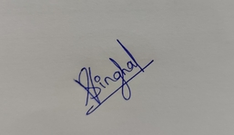

Oracle Solution Services India Private Limited  BANGALORE | 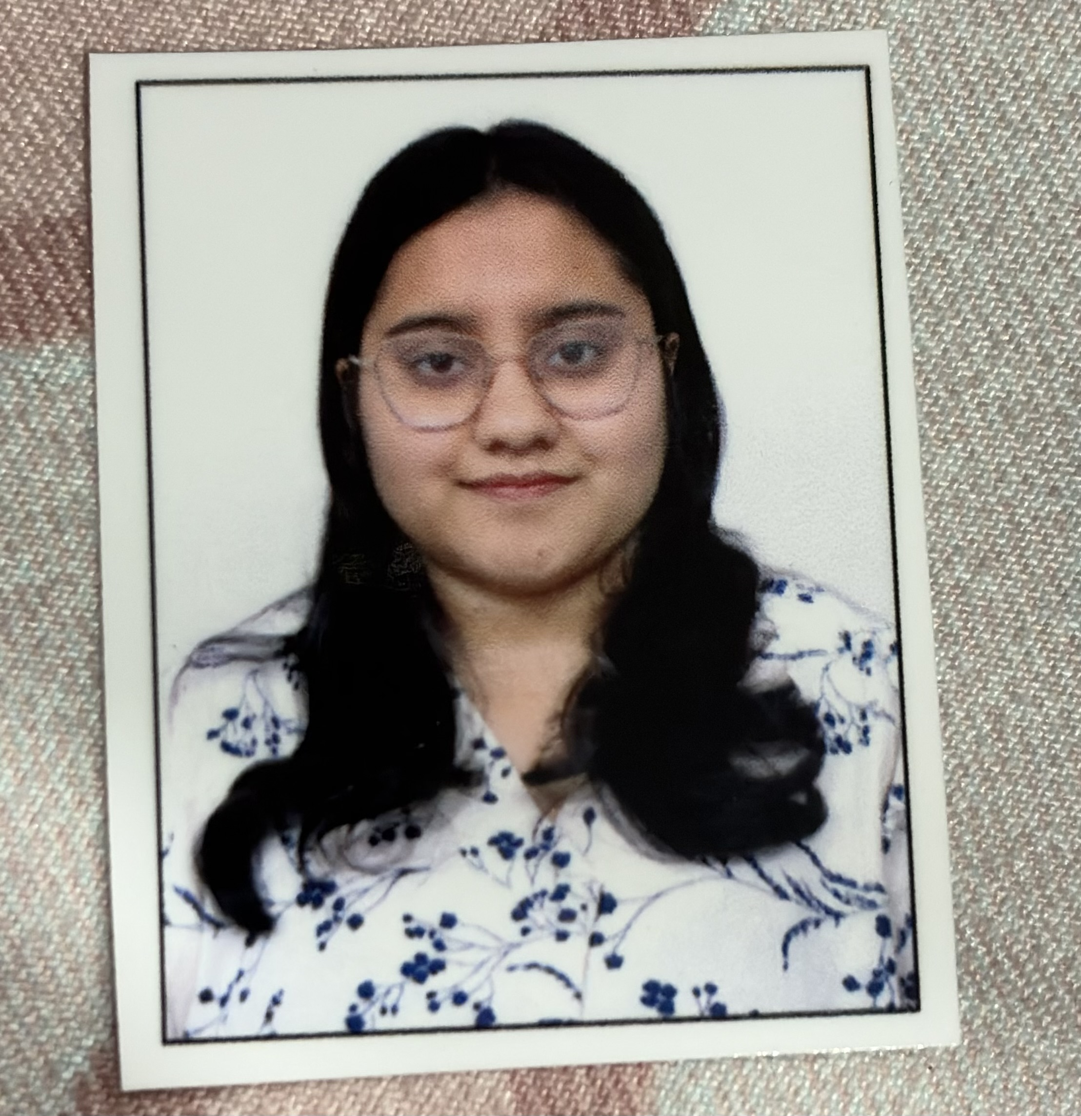

(Please use capital letters only)

Employee No. : | 2141120 | Date of Joining : | 02-Mar-2026
DD MMM YYYY
First Name : | Vanshika
Middle Name :
Last Name : | Singhal

Personal E-mail ID : | vansin0814@gmail.com
Mobile No : | 9406321871

Hire Type : | New Hire | IRC Number : | 318883
Prev. Oracle Empl. No. : |  | Previous Hire Date :
(only in case of transfer/rehire)
Previous Oracle email id :

Citizenship : | Indian | Nationality (country of birth) : | India

Present Address :
House No - E07
Street - 11
Singapore Life City, Phase -1, Nehru Nagar, Junwani Rd, Bhilai- PIN: 490020
Telephone : 9406321871

Permanent Address :
House No - E07
Street - 11
City: Singapore Life City, Phase -1, Nehru Nagar, Junwani Rd, Bhilai,pin: 490020
Signature:
Emergency Contact :
Contact Person | Address | Landmark | Telephone
Neelam Sawadiya | Maternal Aunt,A301, 3Rd Floor, Tower - A, Innovative Aquafront, Lakeview Rd, Doddanekundi, Vibhutipura Extension, Bengaluru, 560037 | HAL old Airport Road | +91 8660804357
Mamta Singhal | Mother,House No- E07, Street-11,, Singapore Life City Phase-1, Near Surya Ti Mall, Bhilai, 490020 | Near Surya TI Mall | +919755886366

Date of Birth : | 14-Aug-2000

Valid passport : | India |  | Place of issue : | Raipur

Passport No : | U8635552

Date of Issue : | 26-May-2022 |  | Expiry Date: | 25-May-2032

PAN No : | NNMPS7739L

UAN No : | 101837550027

Educational Qualification : (start from S.S.L.C)
Degree / Diploma | Subject/Branch | College & University | Year Passed | % age Marks | Class obtained
10th | CBSE | BSP Senior Secondary School Sector-10, Bhilai | 2015 | 95 | Distinction
12th | CBSE(PCM) | Sri Sankara Vidyalaya Sector – 10, Bhilai | 2017 | 92.4 | Distinction
B.Tech | Electrical Engineering | National Institute of Technology Raipur | 2018 | 86.7 | Distinction
 | :
(Please attach copies of certificates)

Signature:
Previous Experience: (starts from the last employment)
Organization & Location | Designation | Period  From To
Deloitte Usi:Bengaluru | Analyst, Oracle Erp | 27-Jun-2022 | 27-Feb-2026
 | :
 | :
 | :
 | :
 | :
 | :

Signature:

Personal Information: (parents/spouse/children)
Relation | Name | Age | Birthday
father | Ravi Singhal | 53 | 6-Apr-1973
mother | Mamta Singhal | 50 | 24-Sep-1976
spouse | Not Applicable
child 1 | Not Applicable
child 2 | Not Applicable
Child 3 | Not Applicable | <<PI6_Age>>

Date: 02-Mar-2026 Signature:

Dear Vanshika Singhal,

Oracle is committed to the highest standards of ethics and business conduct in its vision to be the first choice for all our stakeholders.
Oracle’s success now and in the future depends on the adherence of its employees to an exemplary standard of ethics and business conduct.
Enclosed is your personal copy of the Oracle Code of Ethics and Business Conduct. This code sets forth expected standards of ethics and business conduct and provides a reporting mechanism for addressing such issues. It is imperative you read and understand the contents of this document and be guided by it in conducting company business. The reference to USA specific terms extends to the parallel statute in India also.
The following Chief Legal and HR Officers will function as Business Conduct Officers:
Country/Region Legal Representative HR Representative

Asia Pacific Michael Wilde Rachna Sampayo

Oracle will not be tolerant of any non-compliance, which will result in appropriate discipline, including termination of employment.
Please acknowledge your acceptance of the Oracle Code of Ethics and Business Conduct by signing the duplicate copy of this letter and returning it to the Human Resources Department.

Srihari Beldona
Group Vice President - Human Resources

I acknowledge and accept my personal commitment to comply with the Oracle Code of Ethics and Business Conduct.

Name : Vanshika Singhal
Emp Code : 2141120 Date : 02-Mar-2026

(Signature)

To: Oracle Solution Services India Private Limited,
Oracle Tech Hub
Block B, Lvl 4, No. 169/1, Bellandur,
Sarjapur Marathahalli Ring Rd, Kadubeesanahalli,
Bengaluru, Karnataka-560103 India

From : Vanshika Singhal
Emp Code : 2141120
Ref : 318883
Dated : 02-Mar-2026

Circumstances that led to my resignation from and non-possession of relieving letter & declare that I would submit by (please mention date of submission):
Proof of employment: 27-Feb-26
Other employment endeavors: 27-Feb-26
At this juncture and before I accept the offer from Oracle, I would like to be the only bearer of following statements:
- I don’t have any legal actions taken against me by Management after my quitting of on 27-Feb-2026 till this time.
- Even in case of any actions taken by management against me, I am the sole bearer of all legal actions against me and I won’t involve my employer Oracle, India in any form in these legal implications.
- I don’t have any form of employment with any organization at the time I join Oracle, India.
- I don’t have any service legal agreements signed with any organization at the time I join Oracle, India.
- I am not bound to any of my previous employers.
- I will hold Oracle, India Private Limited, indemnified if any of my previous employers were to initiate any type of legal action against me.

As I have given a detailed explanation of circumstances before leaving and my responsibilities statements, I would like to further stress that leaving was for a justified cause and not deserting a company.
I look forward for a bright future and growth with Oracle, India.

Signature:

Date: 02-Mar-2026

CONSENT LETTER

Pursuant to joining employment with Oracle India (Oracle Solution Services India Private Limited), I consent to join, as a member, with the employee club formed for the employees of Oracle India in the name and style Funatwork Employees Club – IN-Bengaluru-Oracle Tech Hub Block A, B, C, D & E. I consent to continue membership with the club as long as I am in employment with Oracle India. I will abide by the rules and regulations and byelaws of the club during my membership. I further consent to pay the monthly non-refundable subscription to the club as may be decided by the Management Committee of the club from time to time and authorise Oracle India to deduct such monthly subscription from the monthly salary payable to me.

Name: Vanshika Singhal  Employee No: 2141120 | Signature:

Emp No : 2141120

DISCLOSURE OF INTERESTS
- CONFIDENTIAL-
(This form should be used to list the interests of Oracle employees where such interest may potentially lead to any conflict between the Interests of the employee and the business of Oracle Corporation, its subsidiaries or partners)

TO: General Counsel, ORACLE ASIA PACIFIC

FAX: +61.2.9900.1615
This Disclosure of Interests is made by:
NAME : Vanshika Singhal
LOCATION : IN-Bengaluru-Oracle Tech Hub Block A, B, C, D & E
JOB TITLE : Senior Cloud Analyst
REPORTING TO : Vijay Anandh Srinivasan
EMPLOYER : ORACLE SOLUTION SERVICES INDIA PRIVATE LIMITED
CONTACT DETAILS : MOBILE : 9406321871
LAND PHONE / FAX : 9406321871
EMAIL-ID : vansin0814@gmail.com
SCHEDULE 1
(All of your personal interests, such as shareholdings in organisations with which Oracle is or may be likely to do business; partnerships; appointments to any Board of Directors or a holding of any other office by you which may give rise to a conflict of interest with Oracle's business)

SCHEDULE 2
(Include all known interests of family, close personal friends and relatives, and other persons as known to you who may derive a benefit or entitlement from doing business with Oracle where that benefit or entitlement is connected in any way with, and which may conflict with the performance of your duties or employment with Oracle)

The contents of this Disclosure of Interest are complete and to the best of my knowledge and belief are fully accurate at the date of signing. I understand that if any other interest or matter not disclosed above arises whilst I am employed by Oracle, I will promptly update this Disclosure of Interest and provide it to my Senior Manager.

Do you have any interest that need to be disclosed to Oracle?

DATED 02-Mar-2026 SIGNATURE:

EMPLOYEE DECLARATION REGARDING AADHAAR NUMBER

To,
M/s Oracle Solution Services India Private Limited,

Sub: Linking of my AADHAAR number with Provident Fund Universal Account Number.

I have been made aware that the Provident Fund Authority (PFA) requires that my Aadhaar Number be submitted for the purpose of enrolling me in the Employee Provident Fund and Employee Pension Scheme and remittance of PF contributions. This is a mandatory requirement in order to obtain a Universal Account Number (UAN) for my enrollment, and there is no alternative.

Accordingly, Oracle Solution Services India Private Limited has requested that I provide my Aadhaar number to submit to the PFA, via the PFA’s online system, for the reasons stated above. I understand that details of my Aadhaar number will be kept in my personnel file and in accordance with Oracle’s Document Retention Policy.

In acknowledgment and agreement of the matters outlined above, I hereby provide the following information:

- My Aadhaar Number : 940342491839

- My name as stated on my Aadhaar Card: VANSHIKA SINGHAL

Yours sincerely,
(Signature)
Name: Vanshika Singhal Date of Signature: 02-Mar-2026
Employee Number: 2141120

Beneficiary (Insurance Program) Nomination Form
Employee Details – To be completed by the employee.
1. Full Name of Member/ Employee |  |  | Vanshika Singhal
2. Date of Birth |  |  | 14-Aug-2000 |  | 3. Gender |  |  |  | Female
4. Marital Status (Use ) |  |  | Single
5. Unique Member / Employee id/ Group Company Code (If any) |  |  | 2141120
6. Address  (Number, Street, City, State, Pin Code) |  |  | , House No - E07,Street - 11, City :Singapore Life City, Phase -1, Nehru Nagar, Junwani Rd, Bhilai  PIN:490020
7. Company Name |  |  | ORACLE SOLUTION SERVICES INDIA PRIVATE LIMITED
8. Nominations Group Personal Accident / Group Term Life
In the event of my death, I wish my benefits under the above mentioned Group Policies be apportioned between my nominated beneficiary (ies) as follows. The following nomination invalidates all such nominations made prior to the date of this nomination.
Sl. No. | Nominee Name | Date of Birth |  | Relationship |  | % of Benefit |  | Appointee Details in case the Nominee is a Minor
1 | Ravi Singhal | 06-04-1973 |  | Father |  | 50% |  | Click or tap here to enter text.
2 | Mamta Singhal | 24-09-1976 |  | Mother |  | 50% |  | Click or tap here to enter text.
3 |  |  |  |  |  | % |  | Click or tap here to enter text.
4 |  |  |  |  |  | % |  | Click or tap here to enter text.
Total Percentage of Benefits |  |  |  |  |  | 100 %

Signature: | Date: 02-Mar-2026  Place: IN-Bengaluru-Oracle Tech Hub Block A, B, C, D & E
Employer Attestation – to be completed by an authorised personnel of the Company.
Authorised Signatory: | Designation : Director - HR Operations  Date:  Place: IN-Bengaluru-Oracle Tech Hub Block A, B, C, D & E

Date: 02-Mar-2026

From
Name: Vanshika Singhal
Emp No: 2141120

To
ORACLE SOLUTION SERVICES INDIA PRIVATE LIMITED

Subject: Oracle India’s policy on Prevention and Redress of Sexual Harassment

I hereby confirm that I attended the awareness session on Oracle India’s policy on Prevention and Redress of Sexual Harassment on 02-Mar-2026 as part of my new hire orientation program.

I agree to abide by the terms and conditions of the policy in force. I understand the policy including any changes is always available and accessible to employees in Oracle India HR website.

Signature :

Name : Vanshika Singhal
Place : IN-Bengaluru-Oracle Tech Hub Block A, B, C, D & E

EMP NO : 2141120 DOJ : 02-Mar-2026
 | NOMINATION UNDER PAYMENT OF WAGES ACT
1 | Name (in block letters): |  |  | Vanshika Singhal
2 | Father's / Husband's Name : |  |  | Ravi Singhal
3 | Date of birth : |  |  | 14-Aug-2000
4 | Gender : |  |  | Female
5 | Marital Status : |  |  | Single
6 | Permanent Address: |  |  | 9406321871, House No - E07, Street - 11,Singapore Life City, Phase -1, Nehru Nagar, Junwani Rd, ,490020, Bhilai
7 | Temporary Address: |  |  | , House No - E07,  Street - 11, Singapore Life City, Phase -1, Nehru Nagar, Junwani Rd, 490020, Bhilai.
I hereby nominate the person(s) / cancel the nomination made by me previously and nominate the person(s) mentioned below to receive any amount due to me from the employer, in the event of my death.
Sl  No |  | Name of the nominee / Nominees | Address |  | Nominee's relationship with the member | Date of birth | Total amount of share accumulation in credit to be paid to each nominee | If the nominee is minor, name, relationship and address of the guardian who may receive the amount during the minority of nominee.
1 |  | Ravi Singhal | House No - E07,  Street - 11, Singapore Life City, Phase -1, Nehru Nagar, Junwani Rd, 490020, Bhilai. |  | Father | 06-04-1973 | 50% | Click or tap here to enter text.
2 |  | Mamta Singhal | House No - E07,  Street - 11, Singapore Life City, Phase -1, Nehru Nagar, Junwani Rd, 490020, Bhilai. |  | Mother | 24-09-1976 | 50% | Click or tap here to enter text.
3 |  |  |  |  |  |  | % | Click or tap here to enter text.
4 |  |  |  |  |  |  | % | Click or tap here to enter text.

Signature:

- Certified that I have no family and should I acquire a family hereafter, the above nomination shall be deemed as cancelled.
- * Certified that my father / mother is / are dependent upon me.
* Strike out whichever is not applicable.

Signature:

CERTIFICATE BY EMPLOYER

Certified that the above declaration and nomination has been signed / thumb impressed before me by Shri / Smt / Kum. Vanshika Singhal employed in my establishment after he / she has read the entry / entries have been read over to him/her by me and got confirmed by him/her.

Signature of the employer or other authorized
officer of the establishment and Designation
Place: Bangalore
Date: 02-Mar-2026

Name and Address of the Factory /
Establishment and rubber stamp thereof.
Oracle Solution Services India Private Limited,
Oracle Tech Hub
Block B, Lvl 4, No. 169/1, Bellandur,
Sarjapur Marathahalli Ring Rd, Kadubeesanahalli,
Bengaluru, Karnataka-560103 India

Form 11 (Revised) |  | Emp No.: 2141120 ORCL IN OSSI

THE EMPLOYEES’ PROVIDENT FUNDS SCHEME, 1952 (Paragraph 34)
AND
THE EMPLOYEES’ PENSION SCHEME, 1995 (Paragraph 24)
Declaration by a person taking up employment in an establishment in which the Employees’ Provident Funds & Employees’ Pension Scheme enforce

 | 1. Employee ID:2141120 |  |  |  |  |  |  |  |  |  | 2. Name:Vanshika Singhal
 | 3. Aadhar: 940342491839 |  |  |  |  |  |  |  |  |  | 4. Previous Employer EPS Number: NA
 | 5. UAN: 101837550027 |  |  |  |  |  |  |  |  |  | 6. Previous Employer PF Number: AP/HY/37885/097398
 | 7. Mobile No: 9406321871 |  |  |  |  |  |  |  |  |  | 8. Personal Email id: vansin0814@gmail.Com
I |  | Vanshika Singhal  (Name of Employee) |  |  |  |  |  |  |  |  |  | daughter of Sh. |  |  |  |  | Ravi Singhal
 |  | do hereby solemnly declare that :-
(a) |  | I was employed in M/s |  |  |  |  | Deloitte USI Consulting Private Limited, Prestige Tech Park, Kadubeesanahalli, Bangalore  (Name and Full Address of the immediate previous employer)
 |  | and left service on |  |  |  |  | 27-Feb-2026  (Date of leaving with immediate previous employer) |  |  |  |  |  |  |  |  |  |  | prior to that, I was employed in
 |  | (Name and Full Address of the second last employer, if any) |  |  |  |  |  |  |  |  |  |  | from |  |  |  |  |  | to
 |  |  |  |  |  |  |  |  |  |  |  |  | (Date of joining & leaving with second last employer, if any)
(b) |  | I was member of |  |  |  | EPFO  (Name of PF Trust / Address of PF Office of immediate previous employer )
 |  | Provident Fund and but not * of the Pension Fund |  |  |  |  |  |  |  |  |  |  | from |  | 27-Jun-2022 |  |  |  | to | 27-Feb-2026
 |  |  |  |  |  |  |  |  |  |  |  |  | (Date of joining & leaving with immediate previous employer).
 |  | and my account number was |  |  |  |  |  |  |  |  |  | AP/HY/37885/097398  (PF No. with Establishment Code of immediate previous employer)
(c) |  | I have not * withdrawn the amount of my Provident Fund/Pension Fund.
(d) |  | I have not * drawn any superannuation benefits in respect of my past service from any employer.
(e) |  | I HAVE been a member of any Provident Fund.
(f) |  | I am not drawing * Pension under EPS 95.
(g) |  | I am a not holder * of scheme Certificate.
(h) |  |  | Scheme certificate surrender / not surrender *  *Strike out or delete whichever is not applicable.
Date |  |  |  |  | 02-Mar-2026  (Date of joining of employee) |  |  |  |  |  |  |  |  |  |  | Signature
Shri/Smt. Vanshika Singhal is appointed as in M/s Oracle Solution Services India Private Limited with effect from 02-Mar-2026 P.F. Account Number (PF No with Estt Code) KN/23430/
Date |  |  |  | 02-Mar-2026 |  |  |  |  |  |  |  |  |  | Signature of the Employer/Manager or Other Authorised Officer with Office Seal

Emp Code : 2141120 / ORCL IN OSSI

Form No.11 (New)
Declaration Form
(To be retained by the Employer for future reference)

Employees’ Provident Fund Organization

THE EMPLOYEES’ PROVIDENT FUNDS SCHEME, 1952 (PARAGRAPH-34 & 57)
&
THE EMPLOYEES’ PENSION SCHEME, 1995 (PARAGRAPH-24)

DECLARATION BY A PERSON TAKING UP EMPLOYMENT IN AN ESTABLISHMENT ON WHICH EMPLOYEES’ PROVIDENT FUND SCHEME,
1952 AND/OR EMPLOYEES’ PENSION SCHEME, 1995 IS APPLICABLE.


(PLEASE GO THROUGH THE INSTRUCTIONS)

- Name (Title) : Vanshika Singhal
- Date of Birth : 14-Aug-2000
- Father’s / Husband Name : Ravi Singhal
- Relation in respect of (3) above | Father | Husband
(Please Tick)

- Gender | Male | Female | Transgender
(Please Tick)
- Mobile Number : 9406321871
- Email ID (If any) : vansin0814@gmail.Com
- Whether earlier a member of the Employees’ Provident Fund Scheme, 1952?
Please Tick
- Whether earlier a member of the Employees’ Pension Scheme, 1955?
Please Tick
IF RESPONSE TO ANY OR BOTH OF (8) & (9) ABOVE IS YES, THEN MANDATORILY FILL UP THE PREVIOUS EMPLOYMENT DETAILS AT (10, 11&12):

A. PREVIOUS EMPLOYMENT DETAILS

10) the details of the Universal Account Number (UAN): 101837550027
OR Previous PF Member ID :
11) DATE OF EXIT FOR PREVIOUS MEMBER ID (DD/MM/YYYY) 27-FEB-2026
- (A) IF SCHEME CERTIFICATE ISSUED FOR PREVIOUS EMPLOYMENT, THEN SCHEME CERTIFICATE NUMBER: NA
(B) IF PENSION PAYMENT ORDER (PPO) ISSUED FOR PREVIOUS EMPLOYMENT, THEN PPO NUMBER:
NA
B. Other DETAILS

- INTERNATIONAL WORKER
Yes | No

(PLEASE TICK)

IF THE REPLY TO (13) ABOVE IS YES, THEN ENTER THE DETAILS IN 13(A), 13(B) & 13(C):

INDIA | OTHER THAN INDIA (IF YES, PLEASE MENTION NAME OF THE COUNTRY)
13(A) COUNTRY OF ORIGIN (Please Tick)

13(B) PASSPORT NUMBER :

13(C) PASSPORT VALID
D | D | M | M | Y | Y | Y | Y

FROM

D | D | M | M | Y | Y | Y | Y
TO

Illitrate | Non-Matric | Matric | SENIOR SECONDARY | Graduate | POST GRADUATE | Doctor | TECHNICAL PROFESSIONAL
- EDUCATIONAL
QUALIFICATION

(PLEASE TICK)

Married | Unmarried | WIDOW/ WIDOWER | Divorcee
- MARITAL STATUS
(PLEASE TICK)

Yes | No

IF YES, TICK THE CATEGORY
Locomotive | Visual | Hearing
☐ | ☐ | ☐
16) SPECIALLY ABLED
(PLEASE TICK)

17. KYC DETAILS
KYC DOCUMENT TYPE | NAME AS ON KYC DOCUMENT | NUMBER | REMARKS, IF ANY
BANK ACCOUNT-1* | Vanshika Singhal | 50100568415013 | HDFC0000734
NPR/AADHAAR | Vanshika Singhal | 940342491839
PAN No. | Vanshika Singhal | NNMPS7739L
PASSPORT | Vanshika Singhal | U8635552 | 25/05/2032
DRIVING LICENCE | Vanshika Singhal | CG07 20200012184 | 13/08/2040
ELECTION CARD | Click or tap here to enter text. | Click or tap here to enter text.
RATION CARD | Click or tap here to enter text. | Click or tap here to enter text.
ESIC CARD | Click or tap here to enter text. | Click or tap here to enter text.
* Mandatory Field (NOTE: BANK ACCOUNT NUMBER (ALONG WITH IFSC CODE) IS MANDATORY. YOU ARE HOWEVER ADVISED TO PROVIDE ALL KYC DOCUMENTS AVAILABLE WITH YOU IN ADDITION TO MANDATORY KYCS TO AVAIL BETTER SERVICES. SELF-ATTESTED PHOTOCOPIES OF THE DOCUMENTS MUST BE ATTACHED WITH THIS FORM.

C. UNDERTAKING:
A. I CERTIFY THAT ALL THE INFORMATION GIVEN ABOVE IS TRUE TO THE BEST OF MY KNOWLEDGE AND BELIEF.
B. IN CASE, EARLIER A MEMBER OF EPF SCHEME, 1952 AND/OR EPS, 1995,
- I HAVE ENSURED THE CORRECTNESS OF MY UAN/ PREVIOUS PF MEMBER ID.
- THIS MAY ALSO BE TREATED AS MY REQUEST FOR TRANSFER OF FUNDS AND SERVICE DETAILS IF APPLICABLE FROM THE PREVIOUS ACCOUNT AS DECLARED ABOVE TO THE PRESENT P.F. ACCOUNT. (THE TRANSFER WOULD BE POSSIBLE ONLY IF THE IDENTIFIED KYC DETAILS APPROVED BY PREVIOUS EMPLOYER HAS BEEN VERIFIED BY PRESENT EMPLOYER USING HIS DIGITAL SIGNATURE CERTIFICATE).
- I AM AWARE THAT I CAN SUBMIT MY NOMINATION FORM THROUGH UAN BASED MEMBER PORTAL.
DATE: 02-Mar-2026  PLACE:IN-Bengaluru-Oracle Tech Hub Block A, B, C, D & E | SIGNATURE:

DECLARATION BY PRESENT EMPLOYER

A. THE MEMBER Mr./Ms./Mrs. Vanshika Singhal HAS JOINED ON 02-Mar-2026 AND HAS BEEN ALLOTTED PF MEMBER ID …………………………………………...
B. IN CASE THE PERSON WAS EARLIER NOT A MEMBER OF EPF SCHEME, 1952 AND EPS, 1995:
• (POST ALLOTMENT OF UAN) THE UAN ALLOTTED FOR THE MEMBER IS …………………………
- PLEASE TICK THE APPROPRIATE OPTION:
THE KYC DETAILS OF THE ABOVE MEMBER IN THE UAN DATABASE
□ HAVE NOT BEEN UPLOADED
□ HAVE BEEN UPLOADED BUT NOT APPROVED
□ HAVE BEEN UPLOADED AND APPROVED WITH DSC
C. IN CASE THE PERSON WAS EARLIER A MEMBER OF EPF SCHEME, 1952 AND EPS, 1995:
• THE ABOVE MEMBER ID OF THE MEMBER AS MENTIONED IN (A) ABOVE HAS BEEN TAGGED WITH HIS/HER UAN/PREVIOUS MEMBER ID AS DECLARED BY MEMBER.
• PLEASE TICK THE APPROPRIATE OPTION:-
□ THE KYC DETAILS OF THE ABOVE MEMBER IN THE UAN DATABASE HAVE BEEN APPROVED WITH DIGITAL SIGNATURE CERTIFICATE AND TRANSFER REQUEST HAS BEEN GENERATED ON PORTAL.
□ AS THE DSC OF ESTABLISHMENT ARE NOT REGISTERED WITH EPFO, THE MEMBER HAS BEEN INFORMED TO FILE PHYSICAL CLAIM (FORM-13) FOR TRANSFER OF FUNDS FROM HIS PREVIOUS ESTABLISHMENT.

DATE: 02-Mar-2026 SIGNATURE OF EMPLOYER WITH SEAL OF ESTABLISHMENT

E No | 2141120
Loc | Bangalore
FORM 2 (Revised) .
NOMINATION AND DECLARATION FORM FOR UNEXEMPTED/

EXEMPTED ESTABLISHMENTS
Declaration and Nomination Form under the Employees’ Provident Funds and
Employees’ Pension Scheme

(Paragraphs 33 & 61 (1) of the Employees Provident Fund Scheme, 1952 and Paragraph 18 of the Employees’ Pension scheme, 1995)
1 | Name (in block letters) : | Vanshika Singhal
2 | Father’s / Husband Name : | Ravi Singhal
3 | Date of birth : | 14-Aug-2000
4 | Sex : | Female
5 | Marital Status : | Single
6 | Account No. : | KN/23430/
7 | Permanent Address : | 9406321871, House No - E07 Street - 11, Singapore Life City, Phase -1, Nehru Nagar, Junwani Rd, 490020 - Bhilai
8 | Temporary Address : | House No - E07, Street - 11 Singapore Life City, Phase -1, Nehru Nagar, Junwani Rd, 490020 - Bhilai
PART – A (EPF)
I hereby nominate the person(s) /cancel the nomination made by me previously and nominate the person(s) mentioned below to receive the amount standing to my credit in the Employees’ Provident Fund in the event of my death:
Name of nominee/nominees | Address | Nominee’s relationship with the member | Nominee  Date of Birth | % of share | If the nominee is a minor, name & relationship & of the guardian
1 | 2 | 3 | 4 | 5 | 6
Ravi Singhal | House No - E07, Street - 11 Singapore Life City, Phase -1, Nehru Nagar, Junwani Rd, 490020 - Bhilai | Father | 06-04-1973 | 50 | Click or tap here to enter text.
Mamta Singhal | House No - E07, Street - 11 Singapore Life City, Phase -1, Nehru Nagar, Junwani Rd, 490020 - Bhilai | Mother | 24-09-1976 | 50% | Click or tap here to enter text.
 |  |  |  | % | Click or tap here to enter text.
 |  |  |  | % | Click or tap here to enter text.
- * Certified that I have no family as defined in para 2(g) of the Employees’ Provident Fund Scheme, 1952 and should I acquire a Family hereafter, the above nomination should be deemed as cancelled.
- * Certified that my father / mother is / are dependent upon me.
*Strike out or delete whichever is not applicable.

Signature:

Part B (EPS) (Para 18)

I hereby furnish below particulars of the members of my family who would be eligible to receive widow/children pension in the event of my death.

Name of nominee/nominees | Address | Nominee’s relationship with the member | Nominee  Date of Birth | % of share | If the nominee is a minor, name & relationship & of the guardian
Ravi Singhal | House No - E07, Street - 11 Singapore Life City, Phase -1, Nehru Nagar, Junwani Rd, 490020 - Bhilai | Father | 06-04-1973 | 50% | Click or tap here to enter text.
Mamta Singhal | House No - E07, Street - 11 Singapore Life City, Phase -1, Nehru Nagar, Junwani Rd, 490020 - Bhilai | Mother | 24-09-1976 | 50% | Click or tap here to enter text.
 |  |  |  | % | Click or tap here to enter text.
 |  |  |  | % | Click or tap here to enter text.

** Certified that I have no family, as defined in para 2(vii) of Employees’ Pension Scheme, 1995 and should I acquire a family hereafter I shall furnish particulars thereon in the above form.

I hereby nominate the following person for receiving the monthly widow pension (admissible under para 16 2(a)(i) and (ii) in the event of my death without leaving any eligible family member for receiving Pension.

Name of nominee/nominees | Address | Nominee’s relationship with the member | Nominee  Date of Birth | % of share | If the nominee is a minor, name & relationship & of the guardian
Ravi Singhal | House No - E07, Street - 11 Singapore Life City, Phase -1, Nehru Nagar, Junwani Rd, 490020 - Bhilai | Father | 06-04-1973 | 50% | Click or tap here to enter text.
Mamta Singhal | House No - E07, Street - 11 Singapore Life City, Phase -1, Nehru Nagar, Junwani Rd, 490020 - Bhilai | Mother | 24-09-1976 | 50% | Click or tap here to enter text.
 |  |  |  | % | Click or tap here to enter text.
 |  |  |  | % | Click or tap here to enter text.
Date: 02-Mar-2026  Place: IN-Bengaluru-Oracle Tech Hub Block A, B, C, D & E  **Strike out whichever is not applicable | Signature:

CERTIFICATE BY EMPLOYER

Certified that the above declaration and nomination has been signed/thumb impressed before me by Shri/Smt./Kum. Vanshika Singhal employed in my establishment after he/she has read the entries/entries have been read over to him/her by me and got confirmed by him/her.

Place : Bangalore
Signature of the employer or other
Authorised Officers of the Establishment.

Designation
Dated : 02-Mar-2026

Oracle Solution Services India Private Limited,
Oracle Tech Hub , Block B, Lvl 4, No. 169/1, Bellandur,
Sarjapur Marathahalli Ring Rd, Kadubeesanahalli, Name & Address of the Factory/
Bengaluru, Karnataka-560103 India Establishment or Rubber Stamp Thereon

FORM 'F'
[See sub-rule (1) of rule 6]
Gratuity Nomination Form

To
Oracle Solution Services India Private Limited,
Oracle Tech Hub
Block B, Lvl 4, No. 169/1, Bellandur,
Sarjapur Marathahalli Ring Rd, Kadubeesanahalli,
Bengaluru, Karnataka-560103 India

EMP Id - 2141120

- I, Kumari Vanshika Singhal whose particulars are given in the statement below, hereby nominate the person(s) mentioned below to receive the gratuity payable after my death as also the gratuity standing to my credit in the event of my death before that amount has become payable, or having become payable has not been paid and direct that the said amount of gratuity shall be paid in proportion indicated against the name(s) of the nominee(s).
- I hereby certify that the person(s) mentioned is a/are member(s) of my family within the meaning of clause (h) of section (2) of the Payment of Gratuity Act, 1972.
- I hereby declare that I have no family within the meaning of clause (h) of section (2) of the said Act.
- (a) My father/mother/parents is/are not dependent on me.
(b) My husband's father/mother/parents is/are not dependent on my husband.
- I have excluded my husband from my family by a notice dated to the Controlling Authority in terms of the proviso to clause (h) of section 2 of the said Act.
- Nomination made herein invalidates my previous nomination.
Nominee(s)
 | Name in full with full address of nominee(s) | Relationship with the employee | Age of nominee | Proportion by which gratuity will be shared | If the nominee is minor, name, relationship and address of the guardian who may receive the amount during the minority of nominee
1 | RAVI SINGHAL - House No - E07, Street - 11 Singapore Life City, Phase -1, Nehru Nagar, Junwani Rd, 490020 - Bhilai | Father | 53 | 50% | Click or tap here to enter text.
2 | Mamta Singhal - House No - E07, Street - 11 Singapore Life City, Phase -1, Nehru Nagar, Junwani Rd, 490020 - Bhilai | Mother | 50 | 50% | Click or tap here to enter text.
3 |  |  |  | % | Click or tap here to enter text.
4 |  |  |  | % | Click or tap here to enter text.

Signature :

Statement:
- Name of employee in full: Vanshika Singhal
- Sex: Female
- Religion: HINDU
- Whether unmarried/married/widow/widower: Single
- Department/Branch/Section where employed:ORCL IN OSSI
- Post held with Ticket or Serial No., if any: (2141120)
- Date of appointment: 02-Mar-2026
- Permanent address: 9406321871,House No - E07 Street - 11, Singapore Life City, Phase -1, Nehru Nagar, Junwani Rd, 490020 - Bhilai

Place: IN-Bengaluru-Oracle Tech Hub Block A, B, C, D & E  Date : 02-Mar-2026 | Signature:

Declaration by witnesses:
Nomination signed / thumb impressed before me.
Name in full and full Signature of witnesses.
address of witnesses.
1. NEELAM AGRAWAL 1.
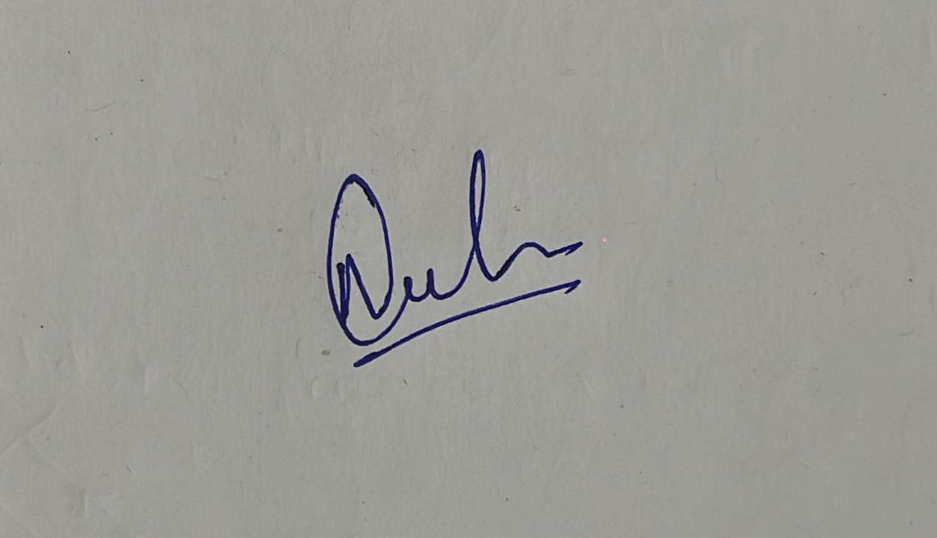

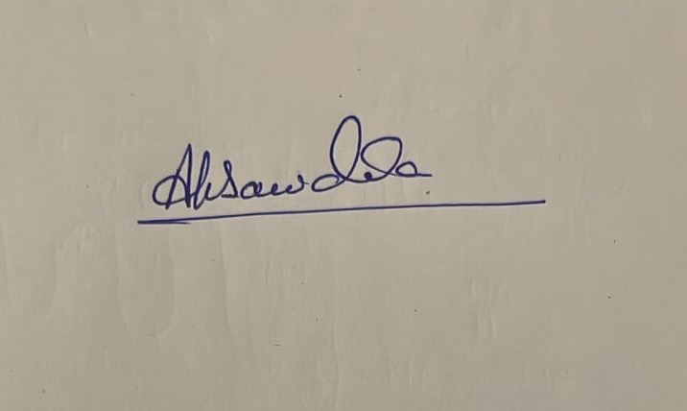
2. ANAND KUMAR SAWADIA 2.

Place: IN-Bengaluru-Oracle Tech Hub Block A, B, C, D & E Date: 02-Mar-2026
Certificate by the employer:
Certified that the particulars of the above nomination have been verified and recorded in this establishment.

Employer's Reference No., if any.

Signature of the employer/officer authorised
Date : 02-Mar-2026 Designation:
Name and Address of Establishment and rubber stamp thereof.
Acknowledgement by the employee:
Received the duplicate copy of nomination in Form 'F' filed by me and duly certified by the employer.

Date : 02-Mar-2026 Signature:

E No | 2141120
Loc | Bangalore

FORM “A”

ORACLE SOLUTION SERVICES (INDIA) PRIVATE LIMITED GROUP SUPERANNUATION SCHEME TRUST
FORM OF APPOINTMENT OF BENEFICIARY

The Trustees,
The Oracle Solution Services(India) Private Limited Group Superannuation Scheme Trust,
Oracle Solution Services India Private Limited,
Oracle Tech Hub
Block B, Lvl 4, No. 169/1, Bellandur,
Sarjapur Marathahalli Ring Rd, Kadubeesanahalli,
Bengaluru, Karnataka-560103 India

Dear Sir,
I, Vanshika Singhal, a member of Oracle Solution Services (India) Private Limited Group Superannuation Scheme Trust hereby appoint in terms of the Rule 20 of the Rules governing the Fund, the following person(s) as my Beneficiary(ies):

NAME & ADDRESS | RELATIONSHIP | AGE | SHARE OF BENEFIT (%)
1. RAVI SINGHAL - House No - E07, Street - 11 Singapore Life City, Phase -1, Nehru Nagar, Junwani Rd, 490020 - Bhilai | Father | 53 | 50%
2. MAMTA SINGHAL - House No - E07, Street - 11 Singapore Life City, Phase -1, Nehru Nagar, Junwani Rd, 490020 - Bhilai | Mother | 50 | 50%
3. |  |  | %
4. |  |  | %

Out of the above Beneficiaries, the under mentioned are unable, at present, to give a legal discharge on account disability stated against their name below:

NAME DISABILITY

1. Click or tap here to enter text.

2. Click or tap here to enter text.

All benefits due and payable to them on and after my demise are hereby authorized to be paid to under-mentioned persons whom I appoint as their Guardian and who have consented to act as such:

 | NAME OF GUARDIAN(S) | APPOINTED FOR  (NAME) | GUARDIAN’S CONSENT TO SUCH APPOINTMENT
1. | Click or tap here to enter text. | Click or tap here to enter text. | Click or tap here to enter text.
2. | Click or tap here to enter text. | Click or tap here to enter text. | Click or tap here to enter text.
3. | Click or tap here to enter text. | Click or tap here to enter text. | Click or tap here to enter text.

Signature:

Name in full and full Signature of witnesses
address of witnesses.
1. NEELAM AGRAWAL 1.

2. ANAND KUMAR SAWADIA 2.

(* The shares of individual Beneficiary should be indicated if there is more than Beneficiary.)

(Provided the above nomination is acceptable to the Trustees with effect from date of this nomination, all earlier nominations made by me stand revoked and cancelled and of no effect:)

The Nomination of the Beneficiary(ies) by the Member ____________________________________

has been accepted.

Date 02-Mar-2026 _____________
(Signature of the Trustees)
Person authorized by the Trustees
in this behalf.

To,
The Trustees – Oracle Software Superannuation Fund
Oracle Solution Services India Private Limited

Sub: Declaration /Undertaking form for self management of Superannuation fund through the trust appointed fund manager.
Employee Name : Vanshika Singhal
Designation : Senior Cloud Analyst
Employee No. : 2141120
Location : IN-Bengaluru-Oracle Tech Hub Block A, B, C, D & E
I, Vanshika Singhal would like to exercise the choice of investing the accumulations / contributions under the Superannuation fund within the various fund options which has been made available. I hereby undertake that I shall be responsible for the gain or loss that may occur in my Superannuation Fund based on my decisions conveyed to the trust appointed fund management company and duly accepted by them. Unless otherwise revised from time to time, I shall be bound by the last instruction given to and accepted by them.

The above undertaking is in addition to my responsibility to be bound by the rules and regulations of the Oracle Software Superannuation Trust of which I am a member.

By virtue of having submitted this declaration / undertaking, I would directly get in touch with the trust appointed fund management company, from time to time, for exercising my fund investment options.

I ACCEPT

Date: 02-Mar-2026

Signature:

Medical Insurance Coverage Form: (parents/spouse/children)

Relation | Name | Age | Birthday
Self | Vanshika Singhal | 25 | 14-Aug-2000

Signature:

Statutory requirement - Consent from women employees

To:
HR Department

Emp Name : Vanshika Singhal

Emp No : 2141120

Location : IN-Bengaluru-Oracle Tech Hub Block A, B, C, D & E

Organisation : M/s Oracle Solution Services India Private Limited

I confirm that I am familiar with the nature of the business of the company and understand that my employment with the company might involve working in different shifts, which may extend after 8.00 PM or working in night shifts.

I undertake to abide by the above requirement and in token thereof, I accord my consent.

Signature :

CANDIDATE / EMPLOYEE DECLARATION FORM

Date: 02-Mar-2026
To,
M/s Oracle Solution Services India Private Limited

Sir,
Sub: Declaration on Aadhaar Updation / Verification with the Universal Account Number (UAN) in Employees Provident Fund Organization (EPFO) portal.

I understand that my Aadhaar updation / verification with Universal Account Number in EPFO portal is mandatory for the remittance of my PF contributions as well as that of the employer i.e., Oracle’s contribution, as per the existing rules of EPFO as per their circulars appended below.

EPFO Circular- I attached in email
EPFO Circular- II attached in email

In view of the above, I am hereby declaring that (select one response as applicable)

Sl. No | Description | Response
1 | I have UAN and my Aadhaar is already updated/verified in EPFO portal
2 | I have UAN and I will update/verify my Aadhaar in the EPFO portal within 5 days of my joining | Click or tap here to enter text.  (Provide Date)
3 | I don’t have UAN and I request Oracle to help me in generating EPFO’s UAN for me based on my Aadhaar details and I undertake to complete KYC updation on the EPFO portal immediately thereafter

Name of the Candidate / Employee: Vanshika Singhal
Employee ID (if given by Oracle): 2141120
Signature of the Candidate / Employee:

To
HR Department
ORCL IN OSSI
Declaration about my Current Address

- I am currently residing in: INDIA (Country name)
- My current address from where I will be residing for the Company upon joining is:
Type the current address here:
22, 5TH Cross Road, Vaikuntam Layout, Lakshminarayana Pura, AECS Layout, Munnekollal, Bengaluru, Karnataka, 560037

- If I am not currently residing in India, I will immediately get in touch with India HR Dept via email to onboarding-hrhelpdesk_in@oracle.com to seek guidance about my joining remotely and abide by that guidance.

Signature

Emp / Candidate Name: Vanshika Singhal

Date: 02-Mar-2026

CANDIDATE / EMPLOYEE DECLARATION FORM

Date: 02-Mar-2026
Emp Name: Vanshika Singhal
Emp No: 2141120

To,

M/s Oracle Solution Services India Private Limited,

Sub: Declaration on Bank account Number

I hereby declare that I will provide accurate details of my Bank Account in the Oracle HCM application, which will enable the Company to credit Salary to the said account mentioned in HCM from the month of my joining the Company.

I take responsibility to update the Bank Account details in the HCM application in case I migrate to any Corporate Salary account i.e. ICICI/HDFC/SBI/Axis Bank.

I hereby take the sole responsibility for the correctness of my Bank Account number and other details provided / updated in the HCM system. I undertake that I will not hold the Company responsible in any manner for any transactions effected by the Company due to incorrect Bank Account number or any other details provided by me.

I understand that in the event I do not update the Bank Account details in the HCM on or before the 18th day of a calendar month, my Salary will not be processed during the payroll cycle for that month; and that only after I update the Bank Account details in the HCM application, the Salary will get credited in the next payroll cycle.

Signature of the Candidate / Employee:

